DFDL using CSV data

1. Click on File and select "New"=>"Library".

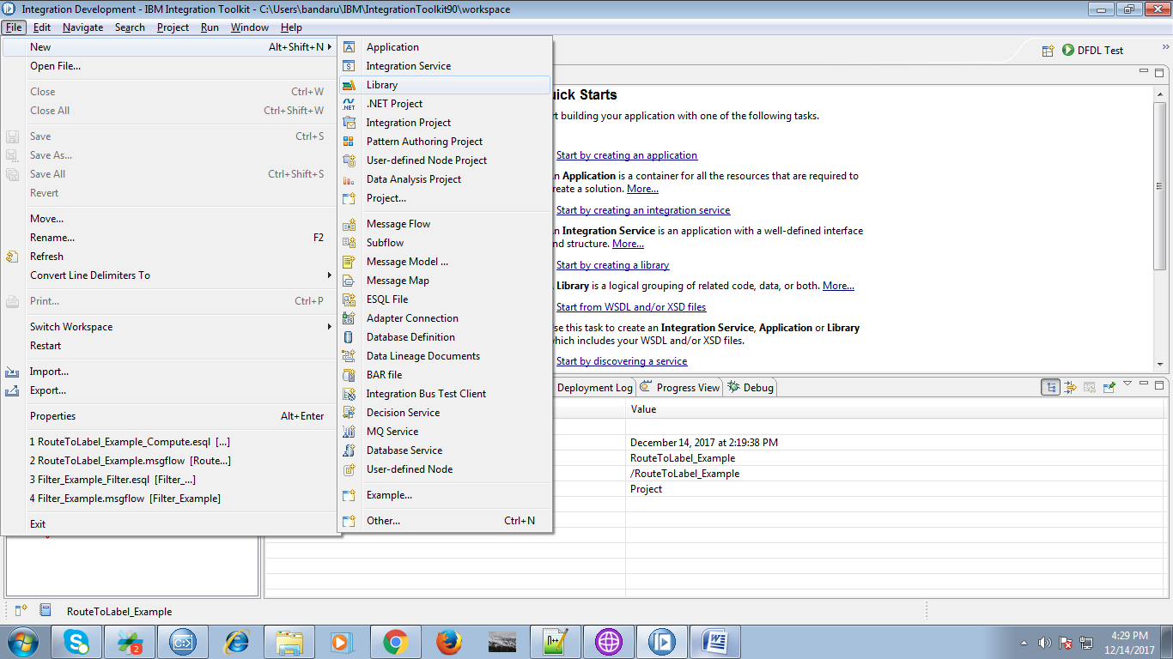

2. Give any name for your library and hit "Finish" button.

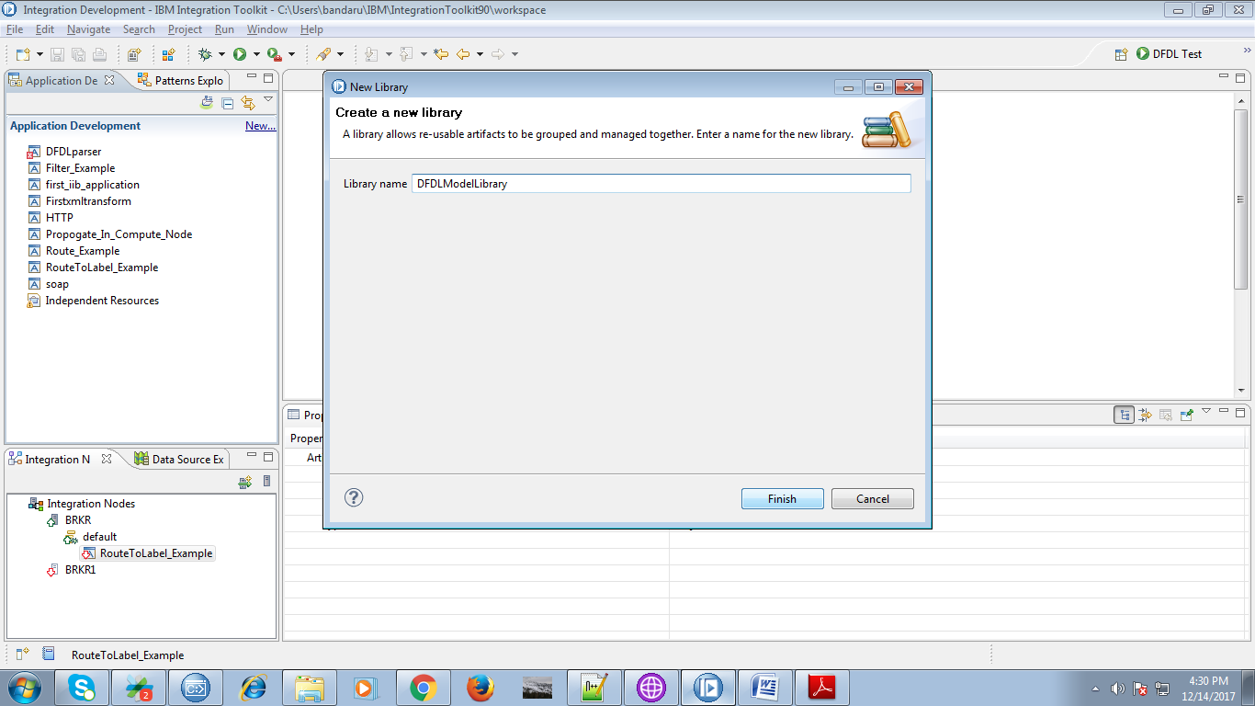

3. Under your created library, you were able to see "New" click on it.

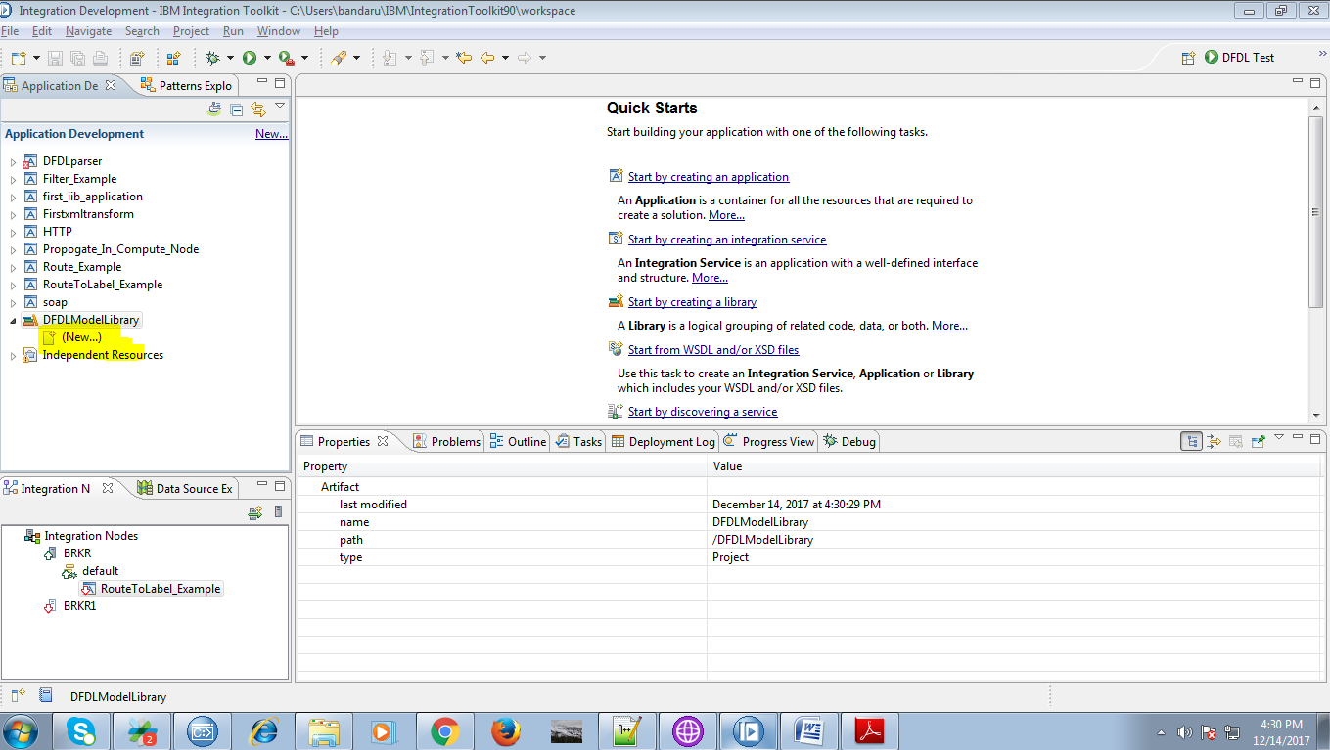

4. Now select "Message Model" from the given options.

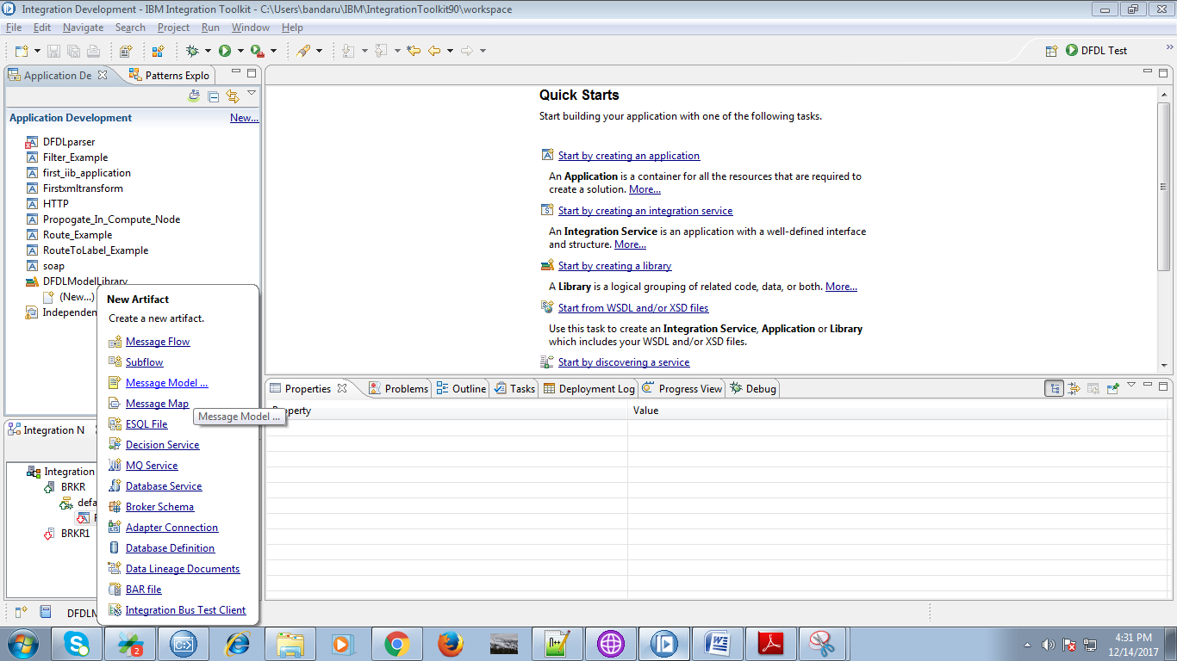

5. Select "CSV text" from the list of formats and hit "Next".

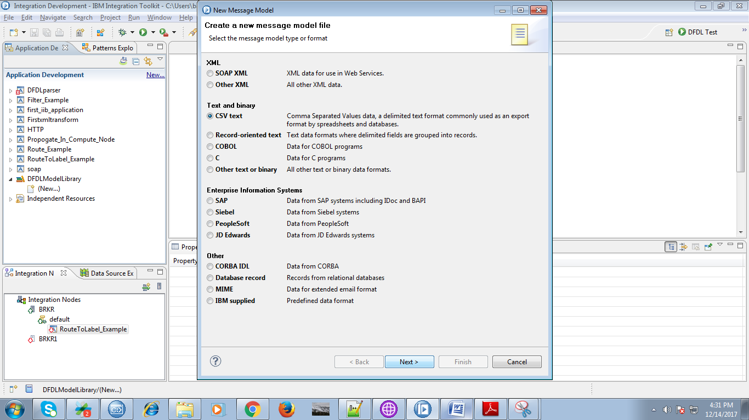

6. select any option and hit "Next".

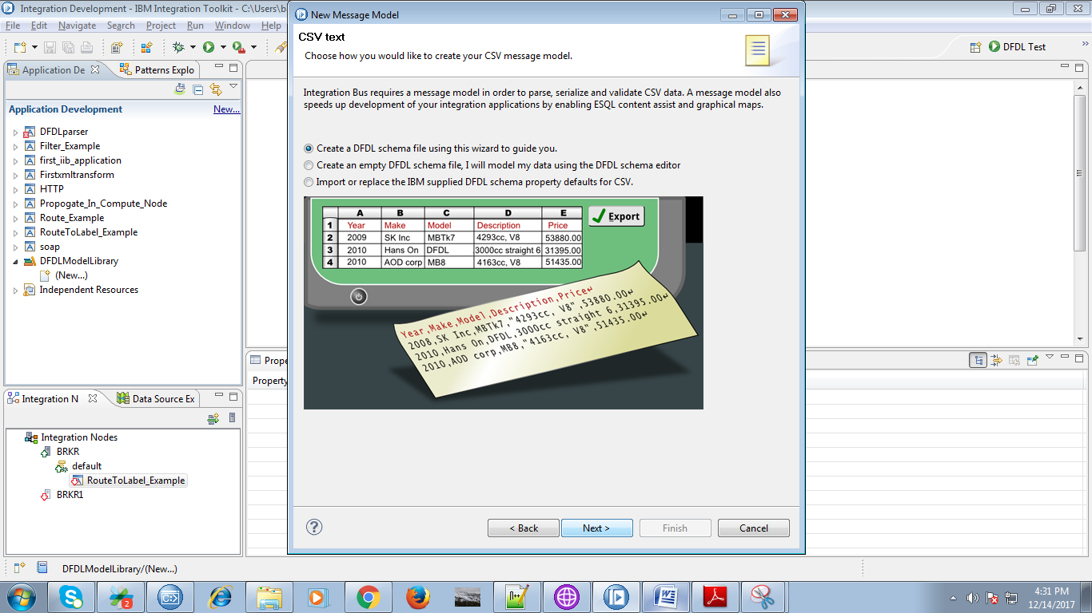

7. Give the "DFDL Schema file name" and "Message name" of your choice and click "Next" button.

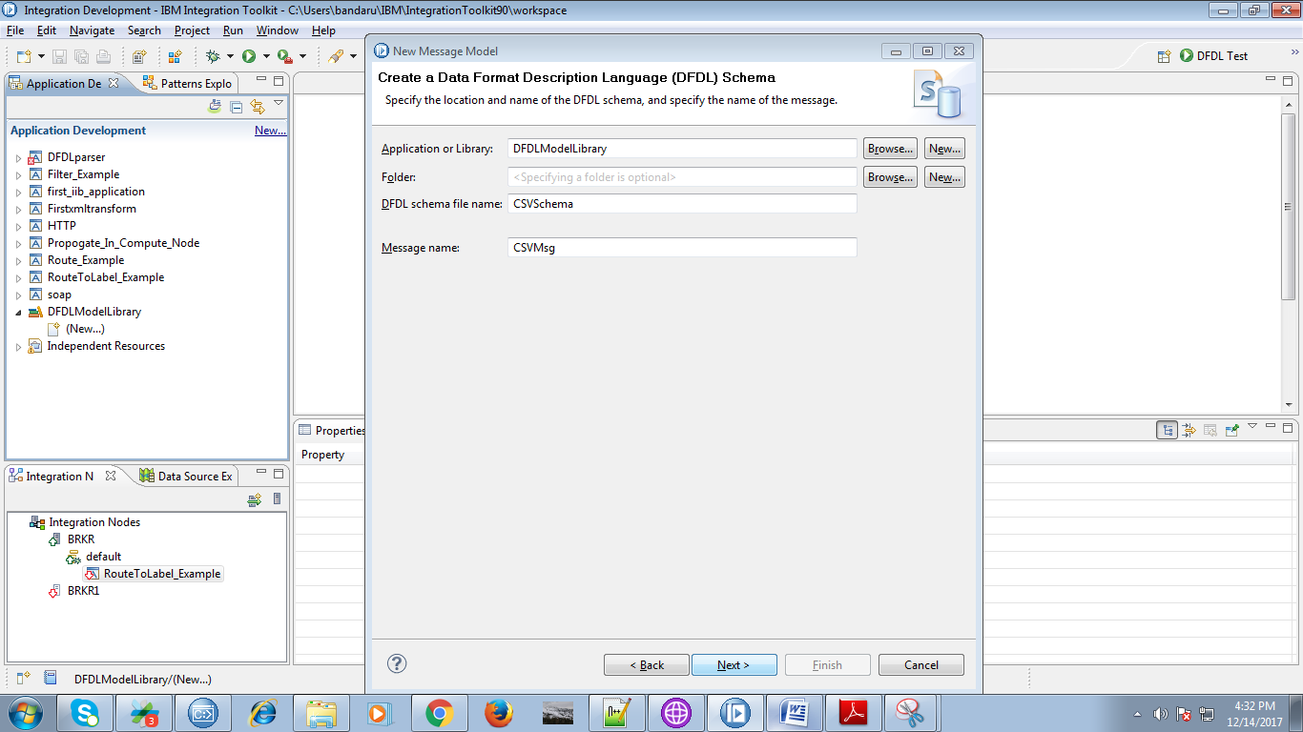

8. Follow the below fig settings and hit "Finish" button.

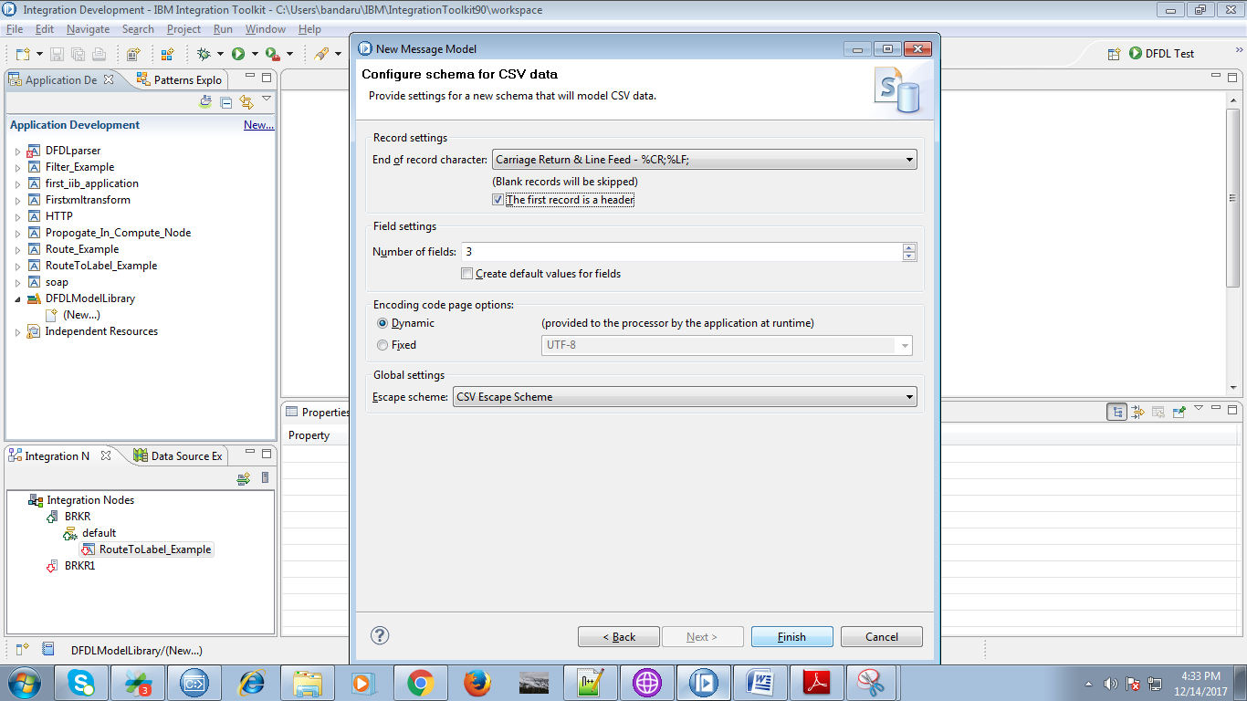

9. As soon as by clicking "Finish" button following will appears.

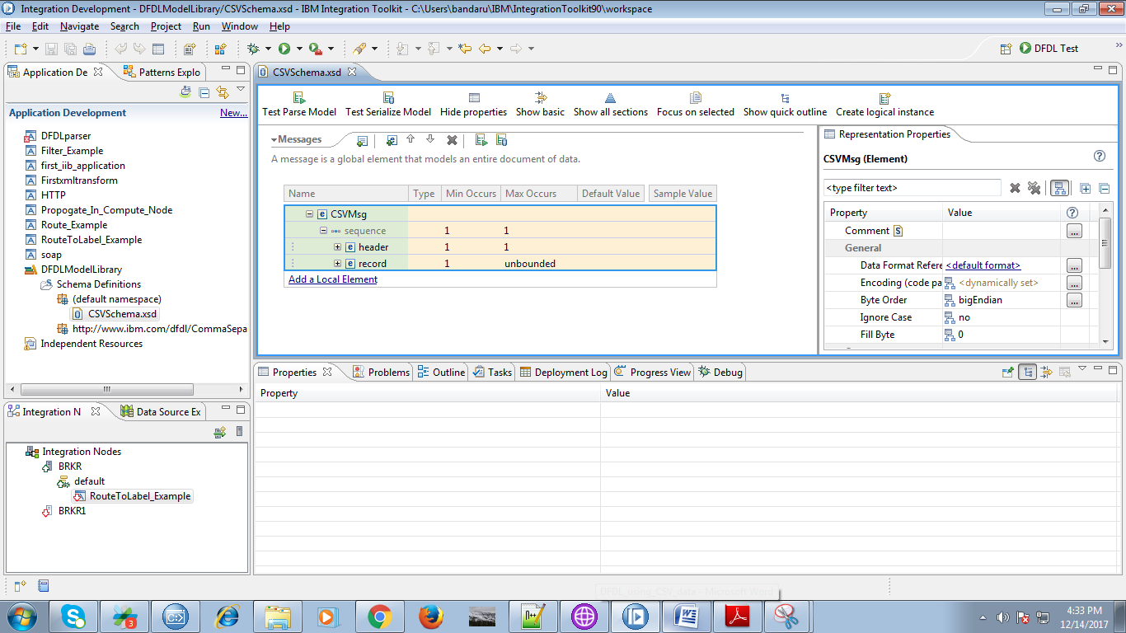

10. Under header section you were able to see header_feilds you can edit them.

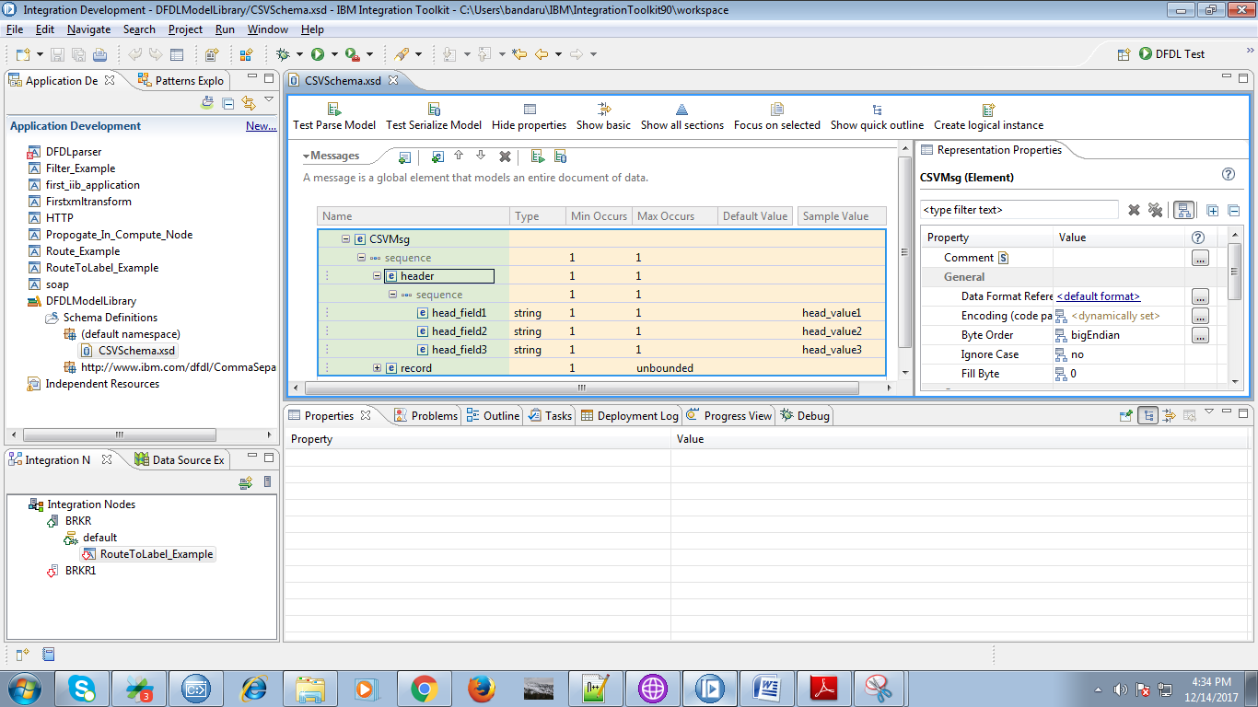

11. Here i edited header values as following.

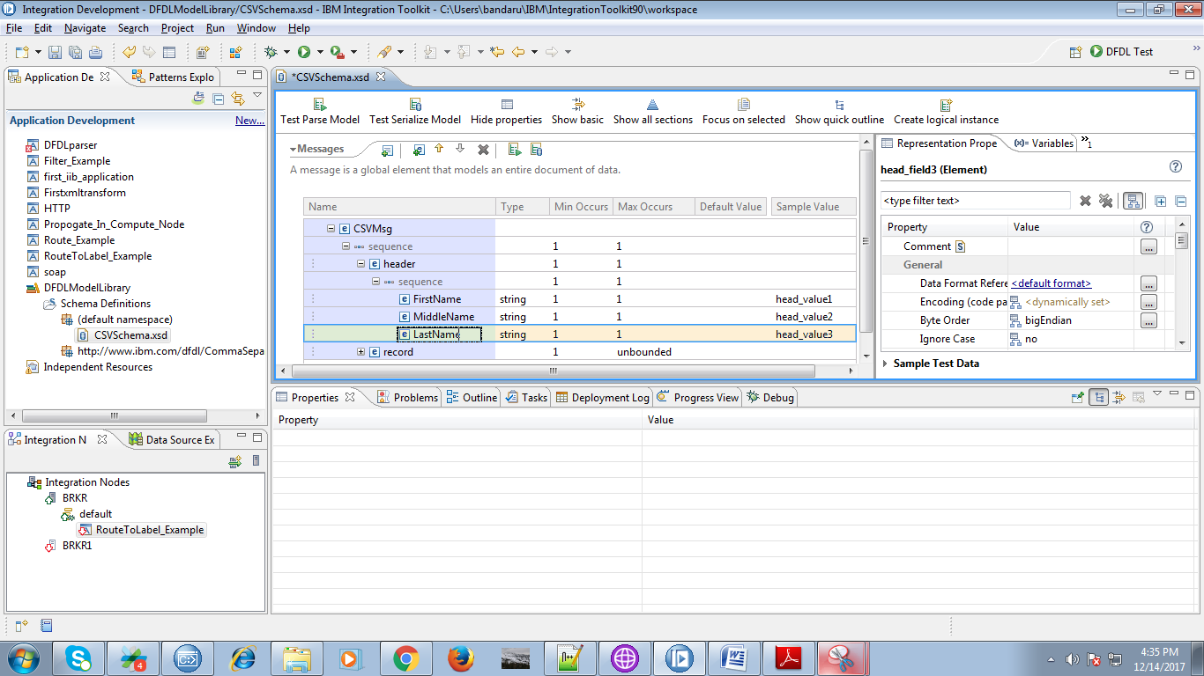

12. Similarly you can edit "Default" and "Sample" values.

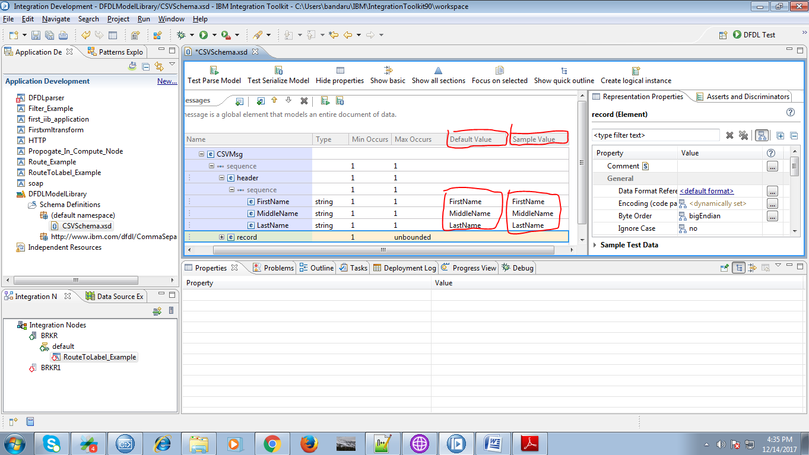

13. Now click on "Test Parse Model" tab.

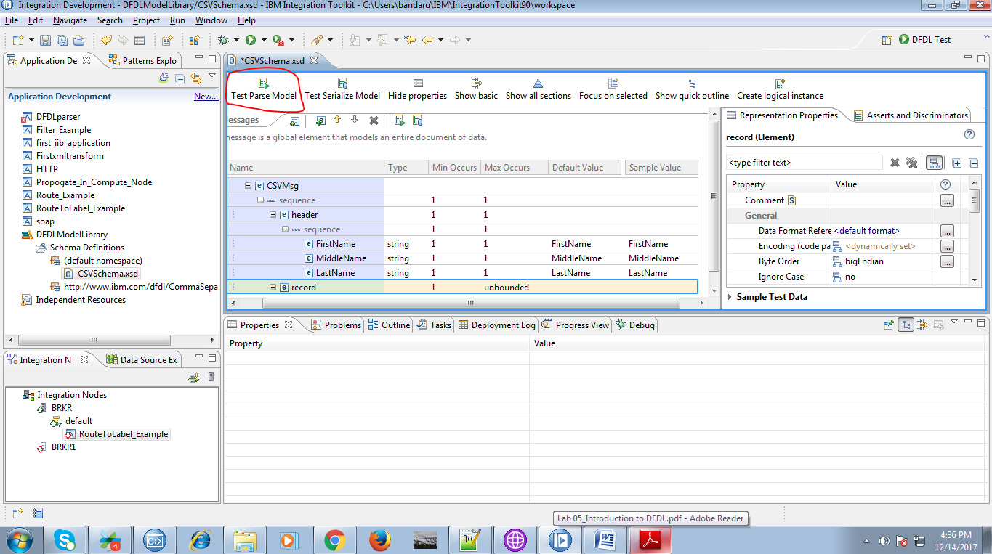

14. A pop-up will appears as below and click "Browse" button.

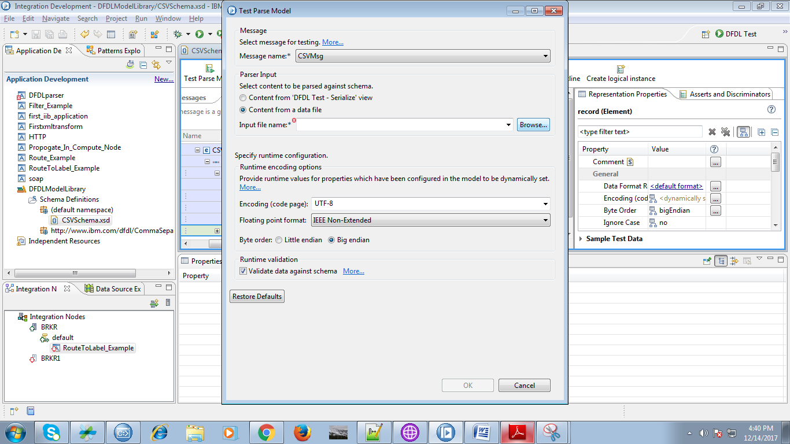

15. Select the checkbox given in below fig and click on "browse" button.

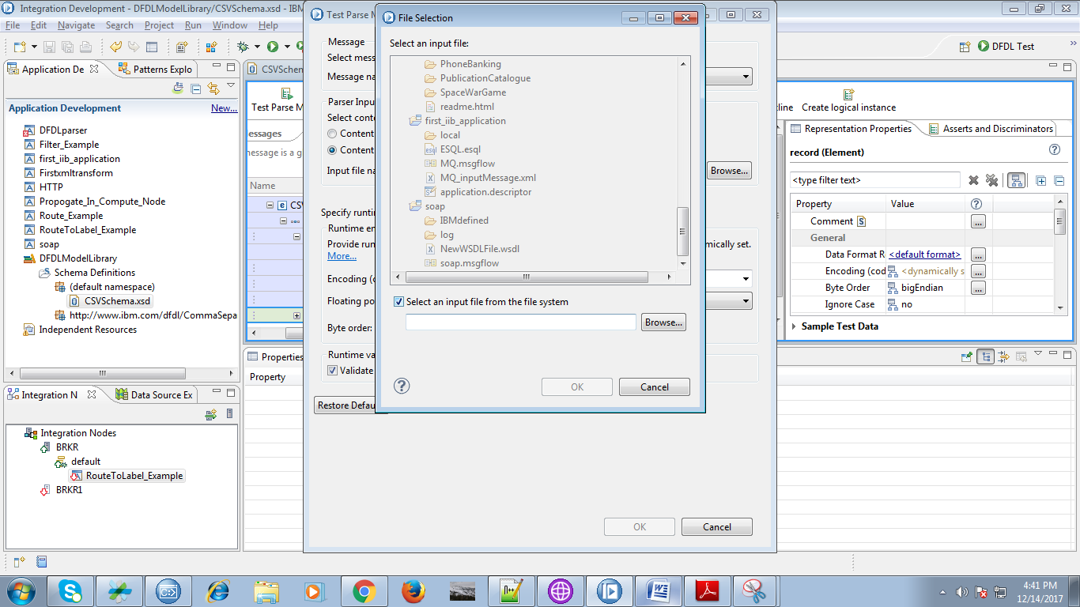

16. Now select the file(csv) file you want to validate.

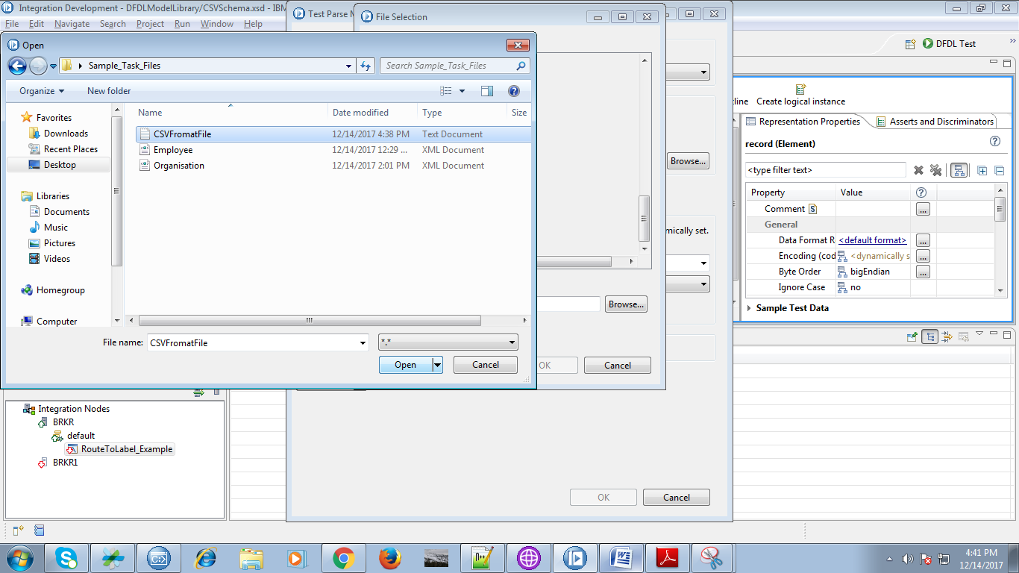

17. After choosing your desired file click on "OK" button as below fig.

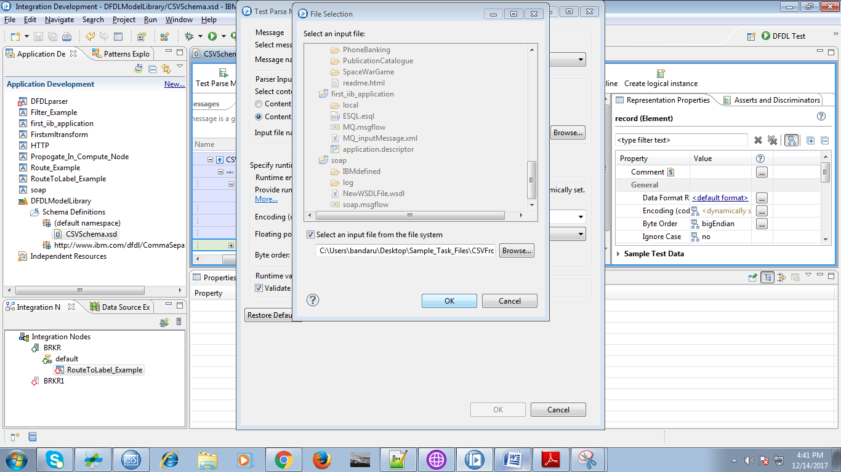

my sample example file contains following data.

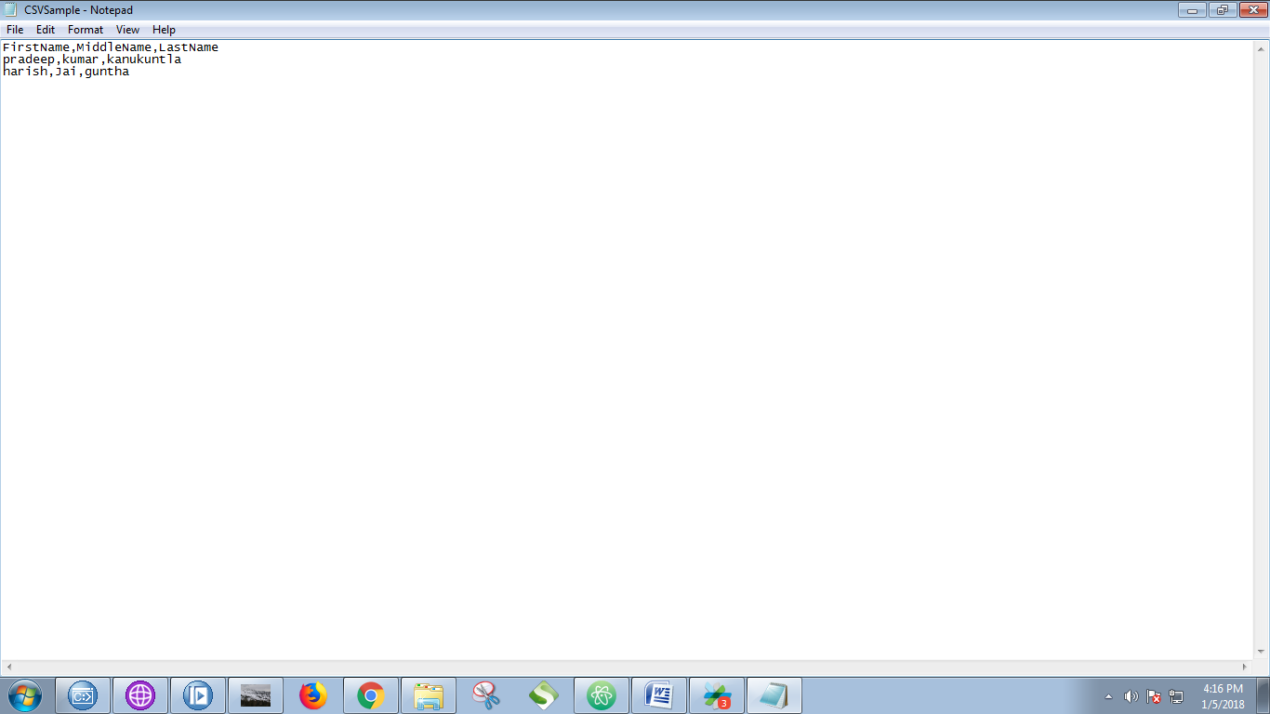

18. Your given file is validated successfully.

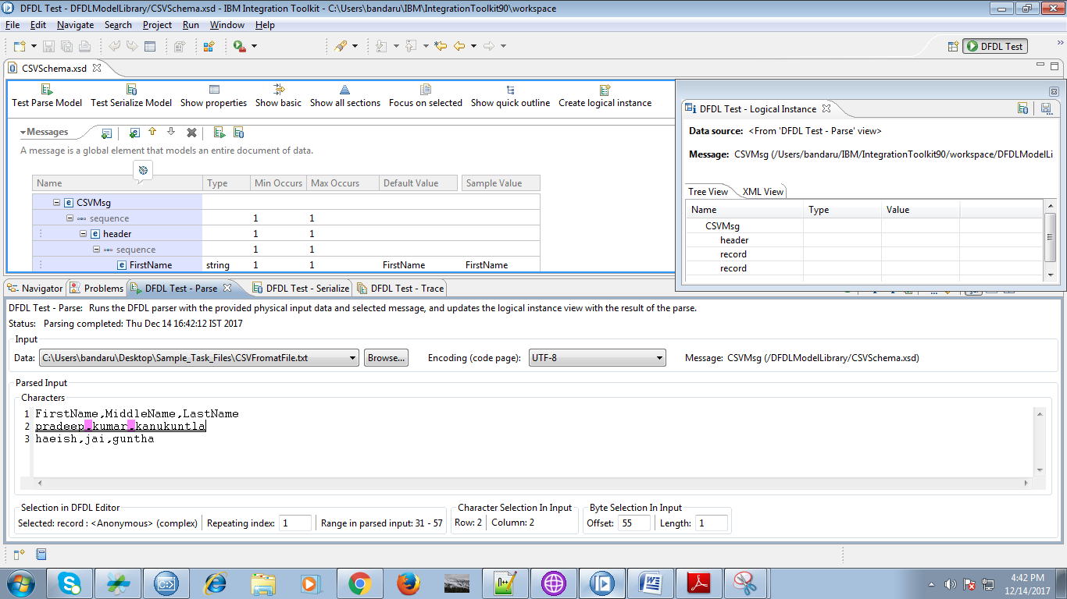

19. Click on File and select "New" => "Application".

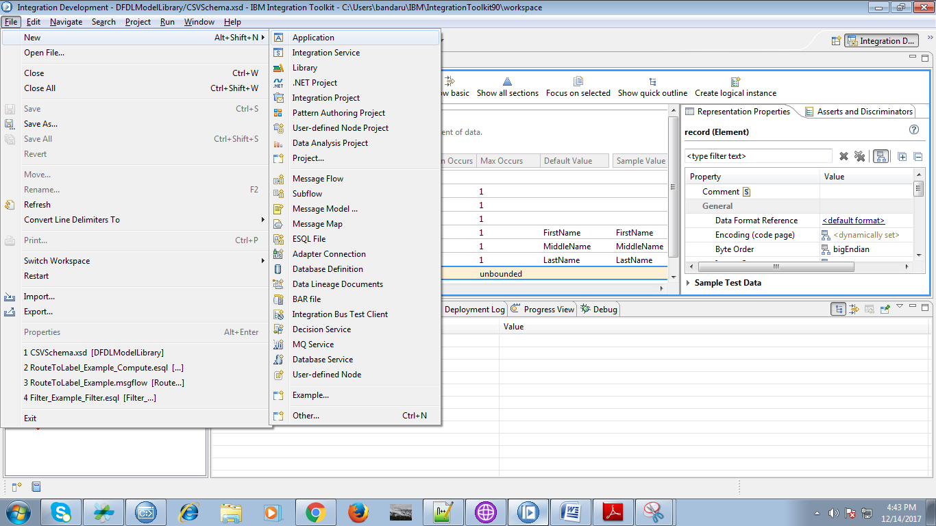

20. Provide a name for your application and click "Finish".

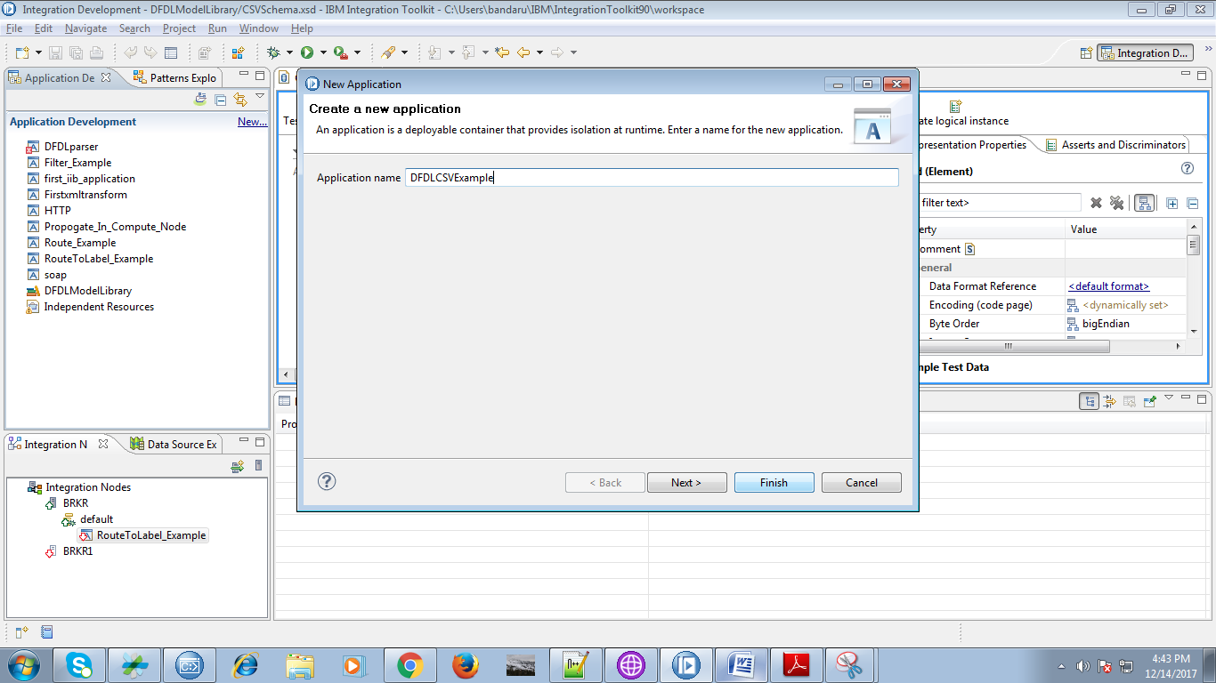

21. When you right click on your application you able to see "Manage Library reference" click on it.

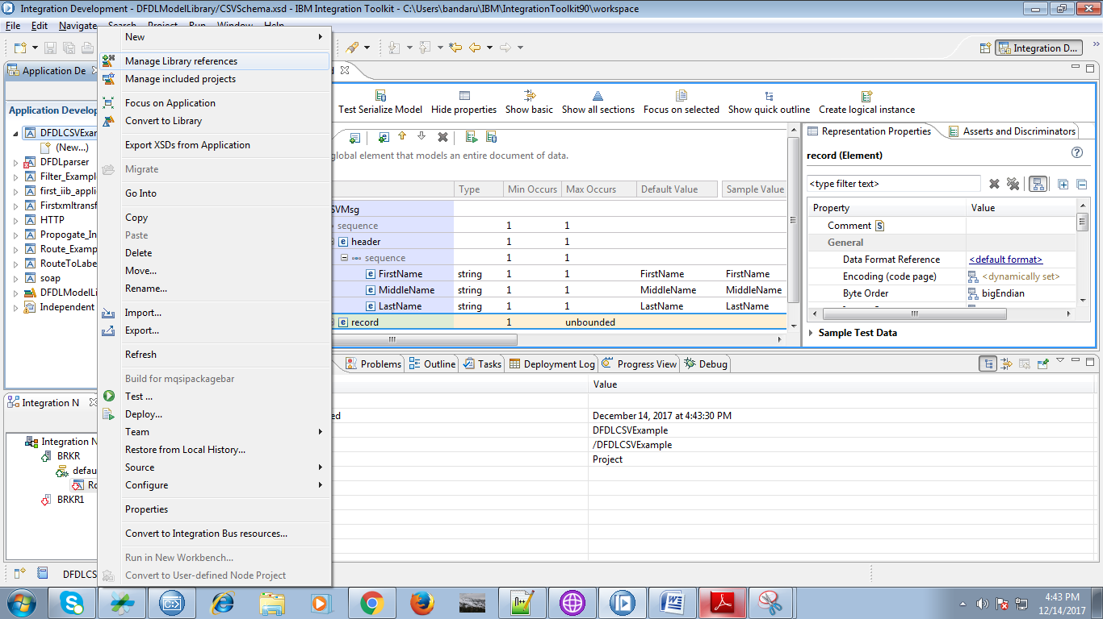

22. Select your library and click on "OK" button.

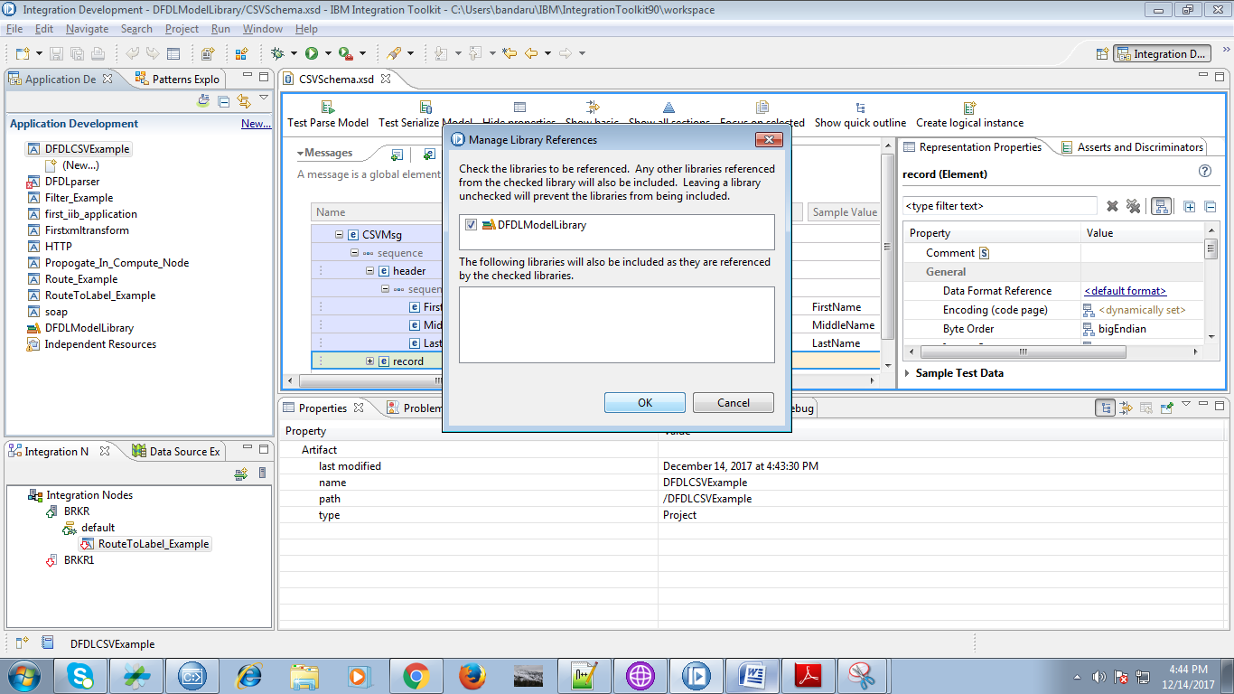

23. Under your application you able to see "New" click on it.

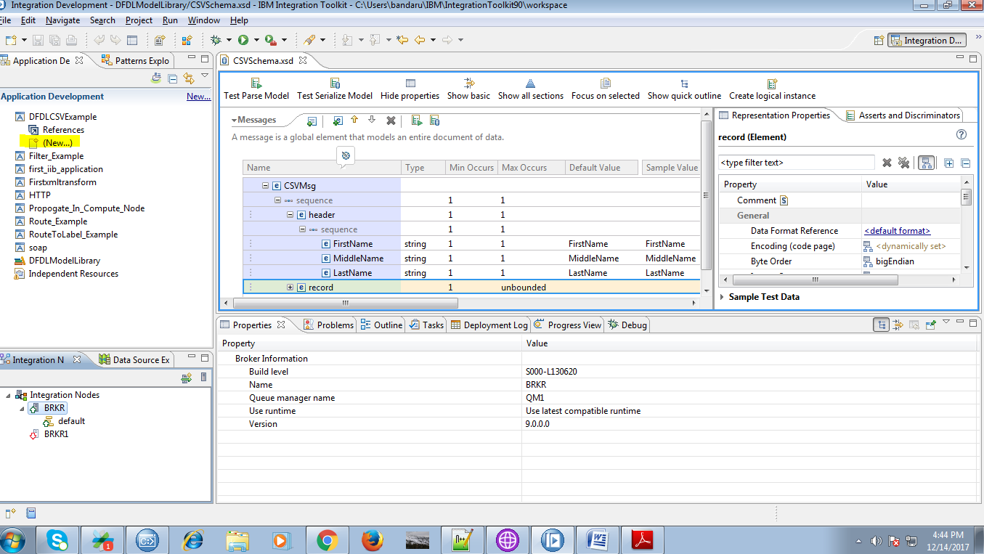

24. Select "Message Flow" under given options.

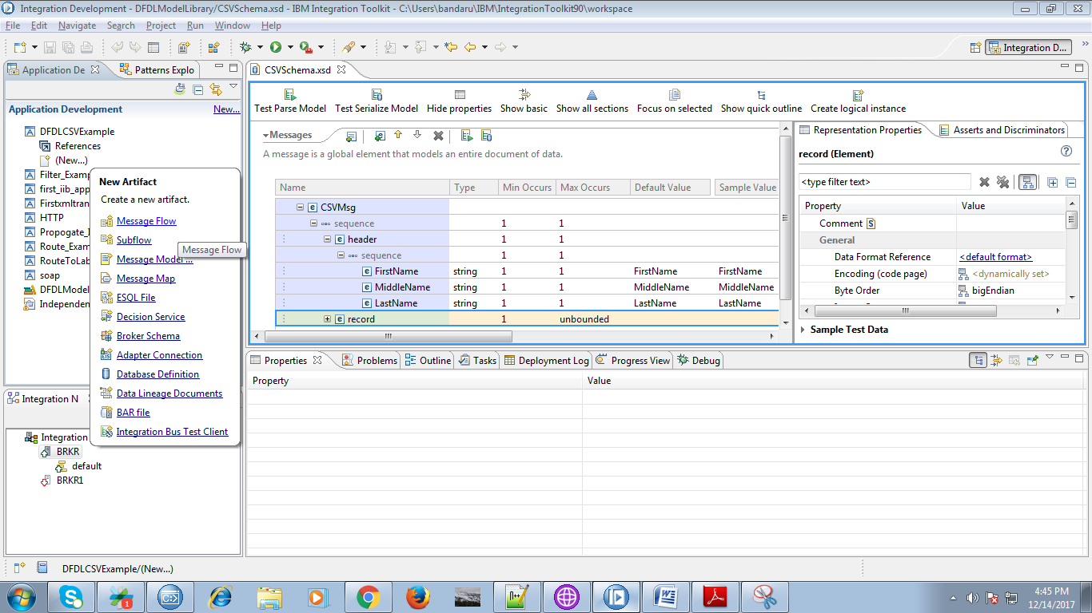

25. Give a name for your flow and hit "Finish" button.

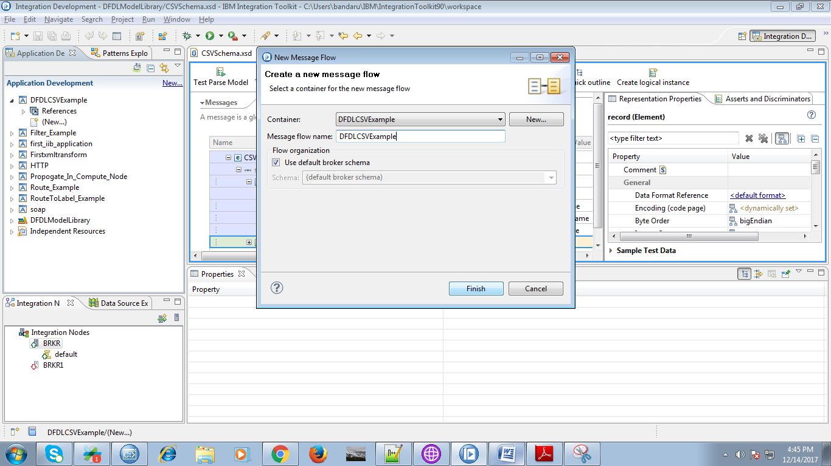

26. Drag file node from file section as shown below fig.

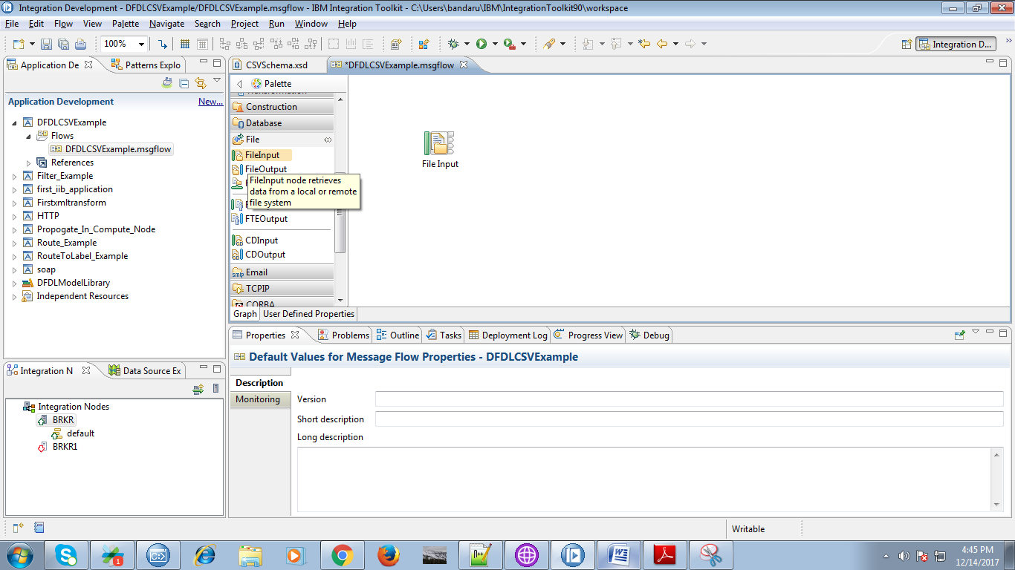

27. Provide file path and file name as give below fig.

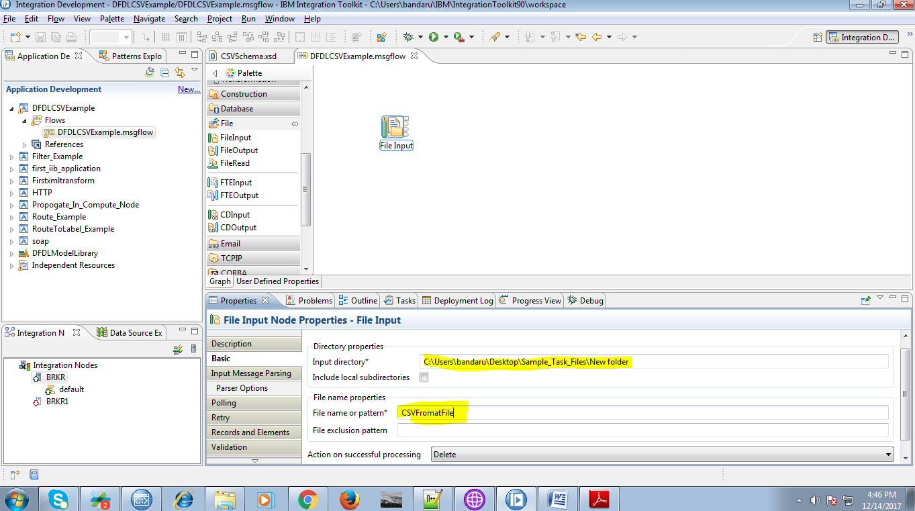

28. Select DFDL as message domainunder "Input Message Parsing" and click "Browse" button.

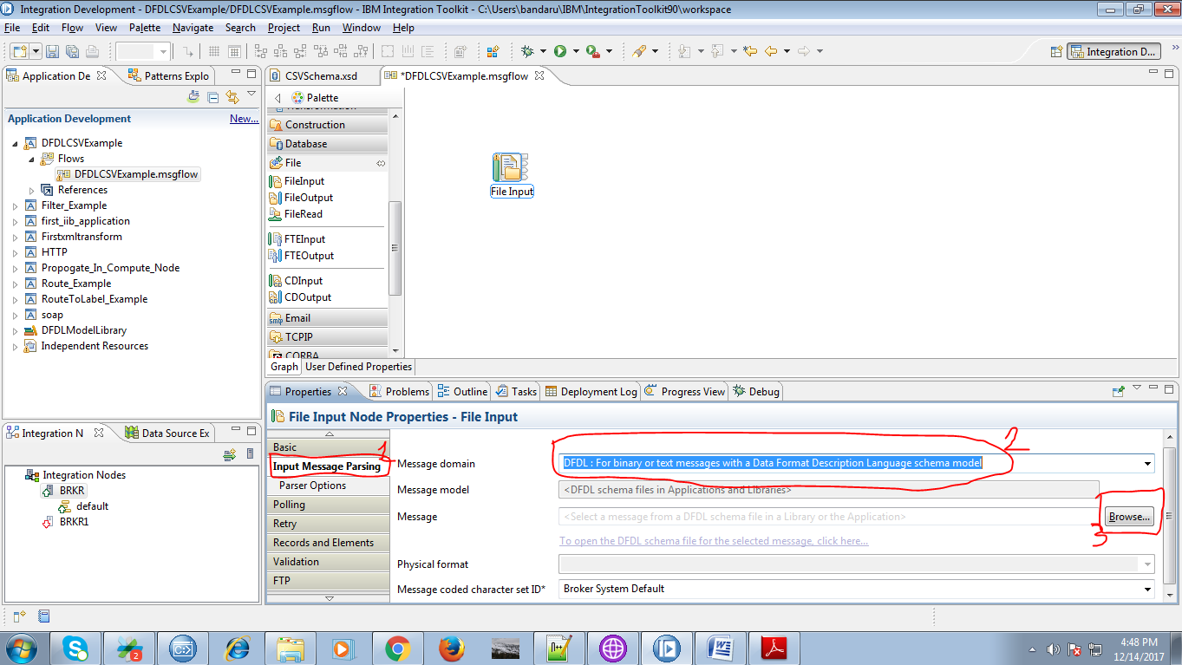

29. Select your DFDL model as given below.

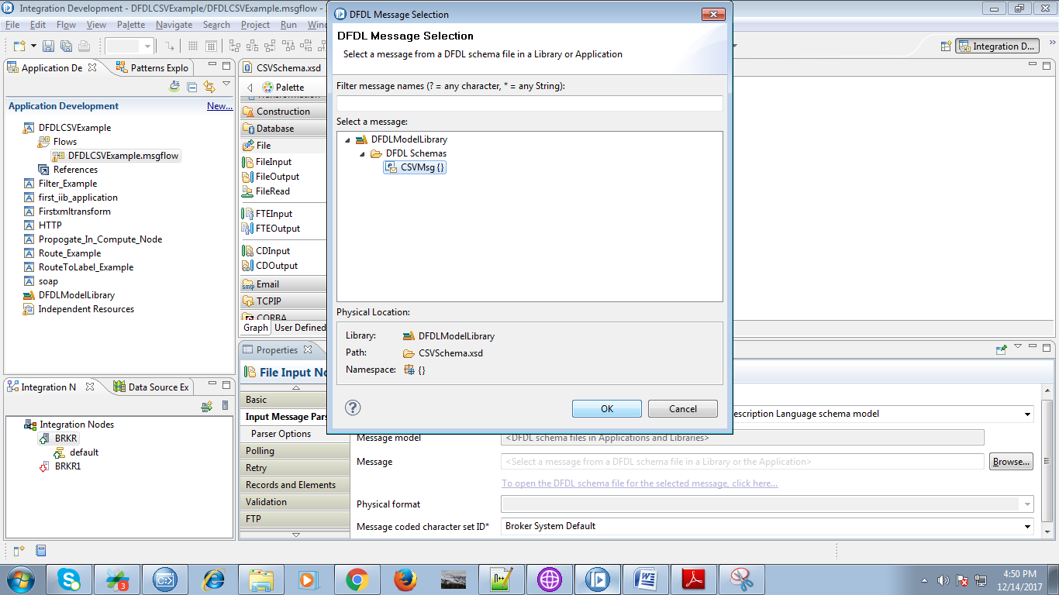

30. Drag compute node from "Transformation" section.

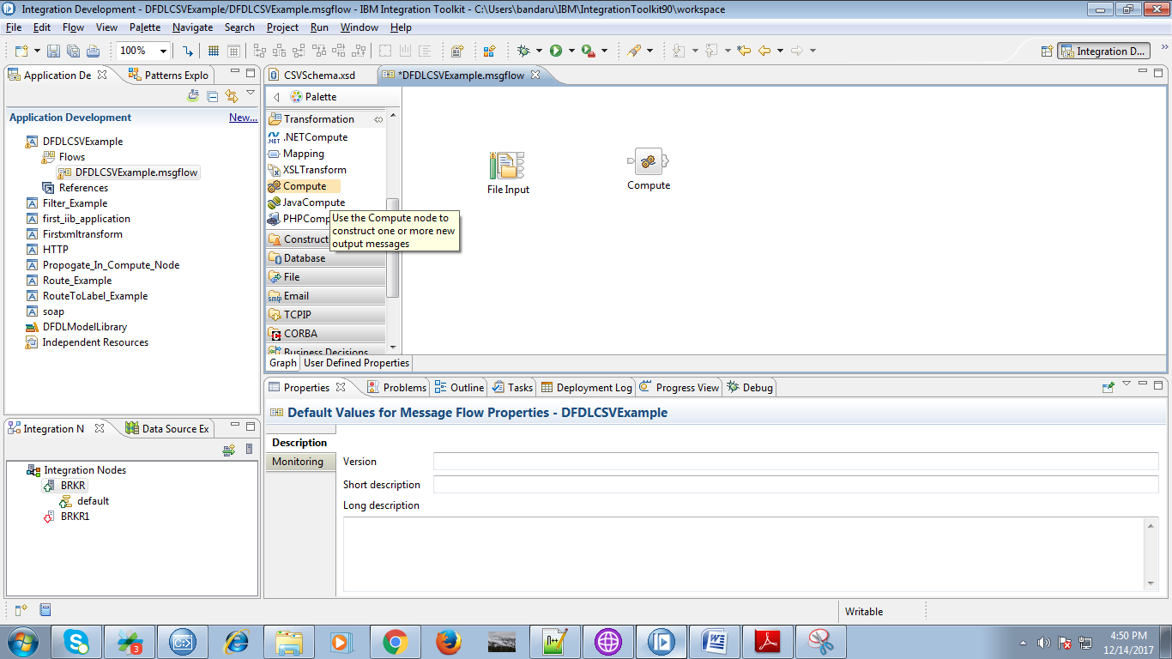

31. Connect "out" terminal of the file node to "input" terminal of the compute node.

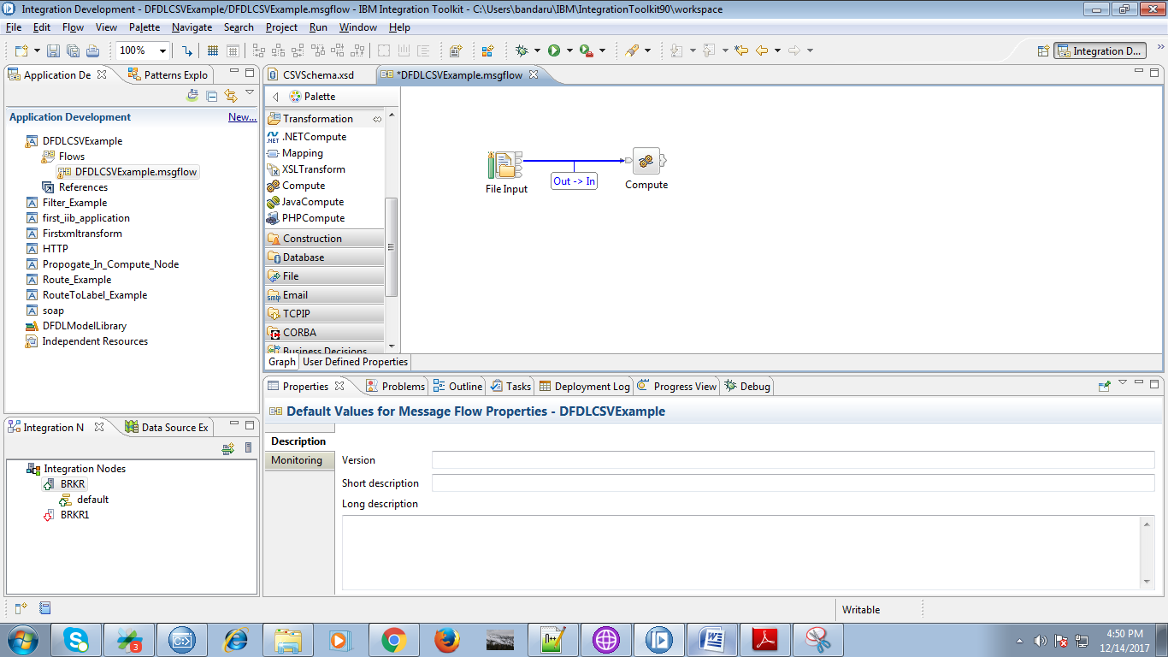

32. Drag "MQOutput" and name it appropriately as given two fig.

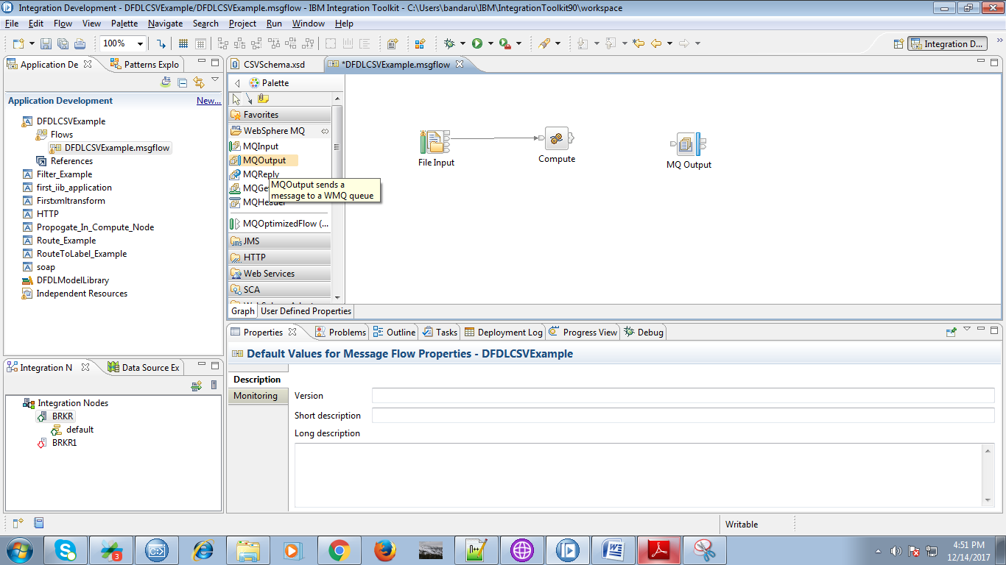

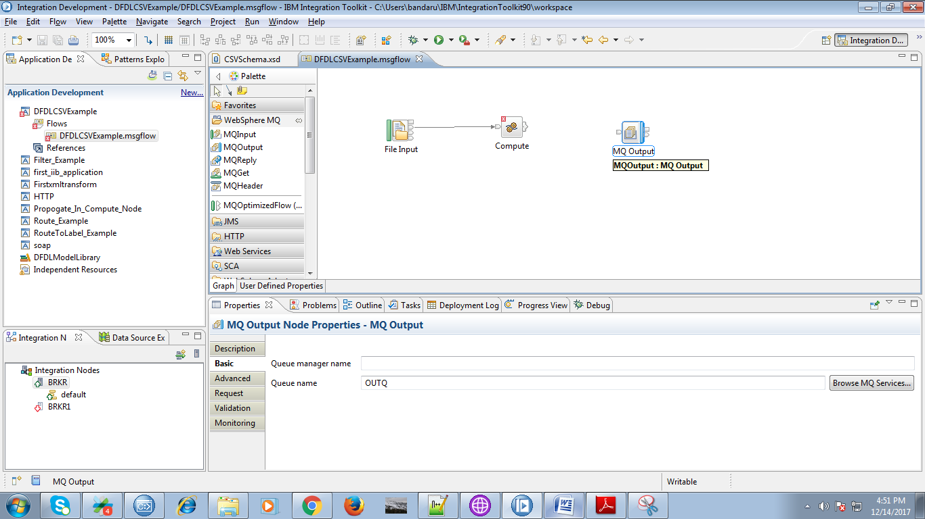

33. Select "Out" terminal of the compute node. as below fig.

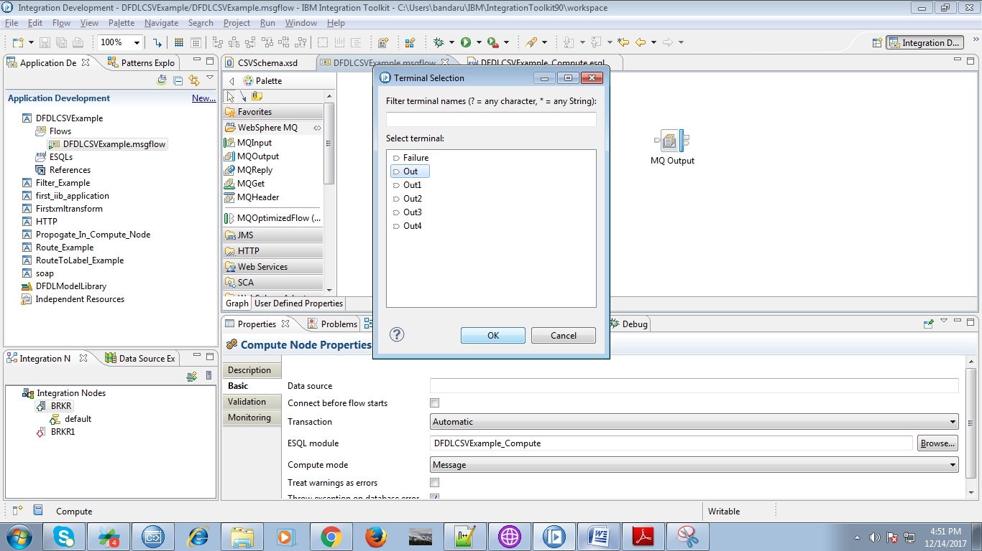

34. Connect "Out" terminal of the compute node with "input" terminal of the output queue.

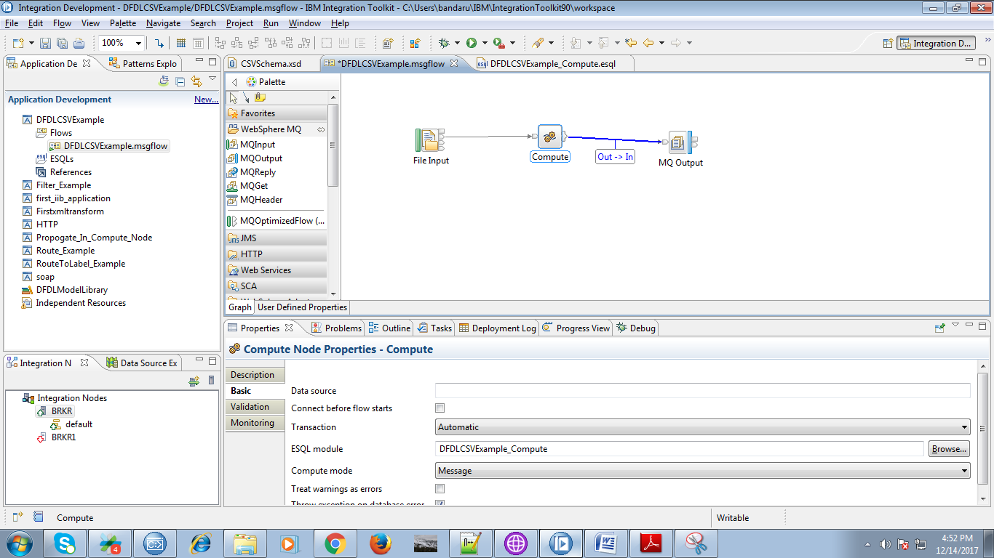

35. Copy the following code in to compute node.

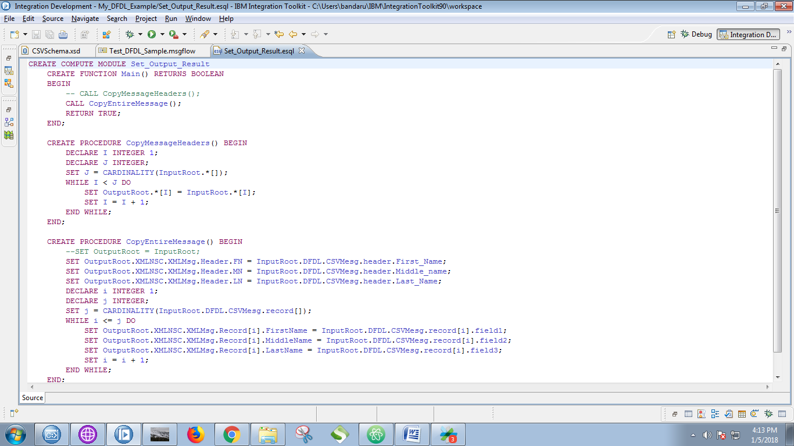

36. Right click on your application and select "Deploy" option, following screen will propmt then select your running broker and execution group and click on "Finish" buttin.

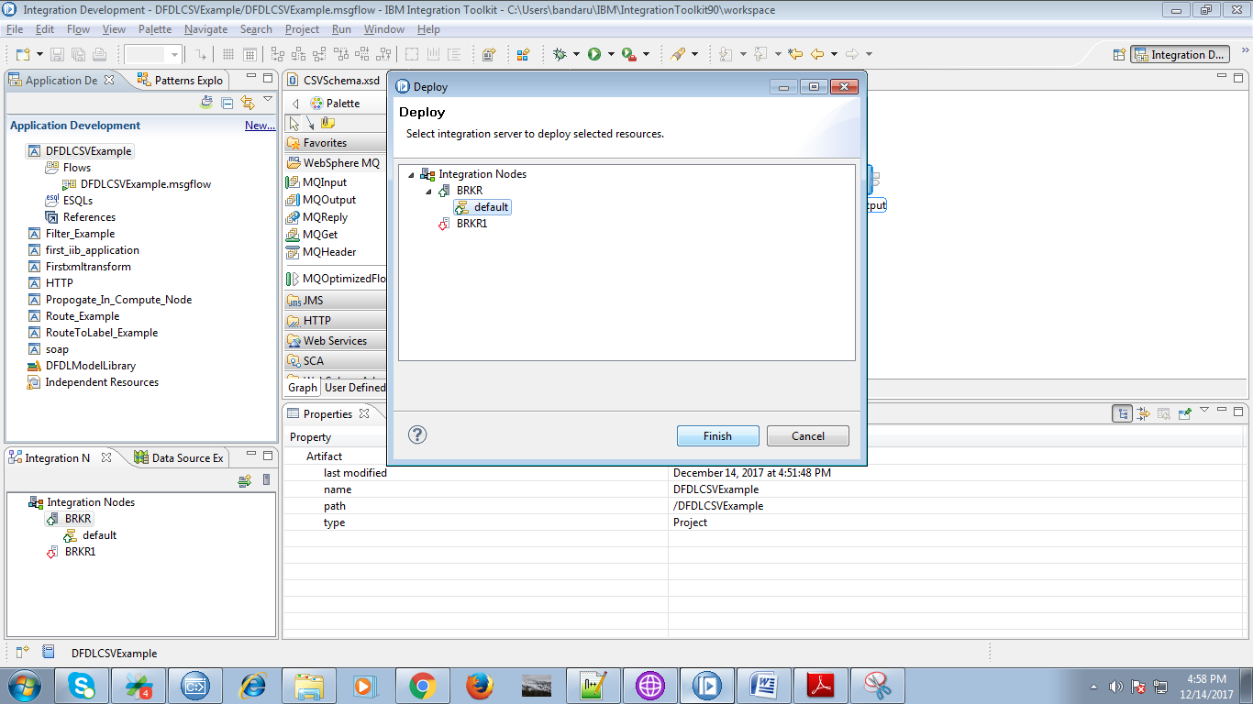

37. You can see the output of the MQInput in debug mode.

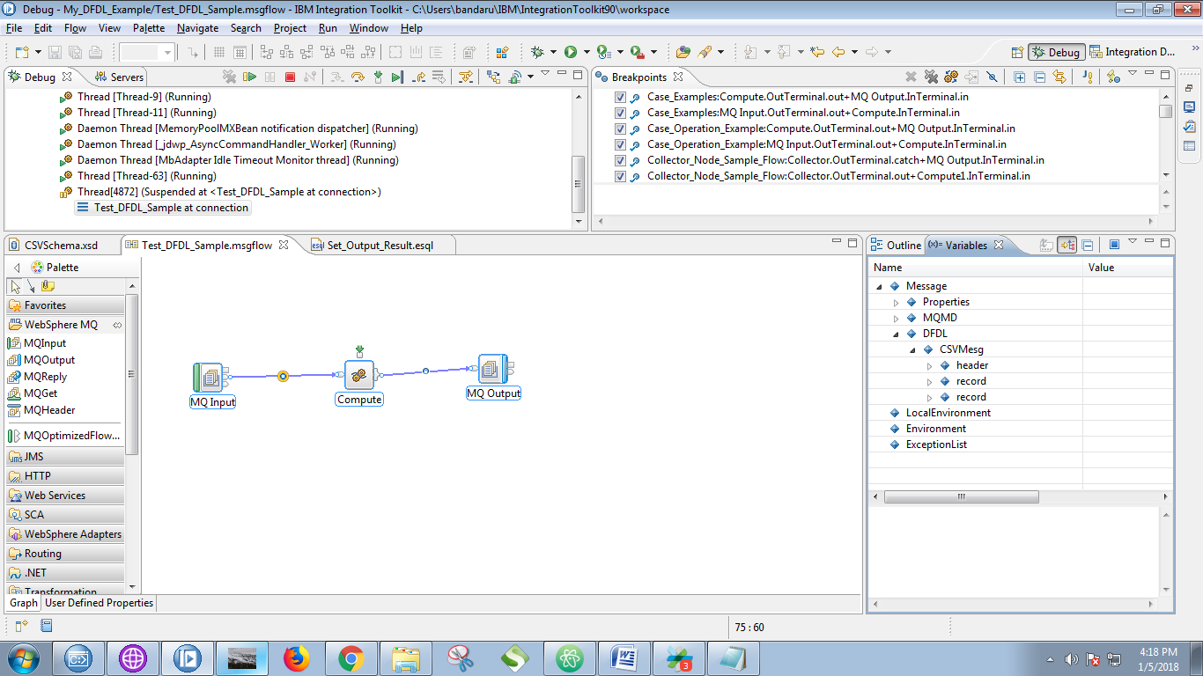

37. Output of the compute node.

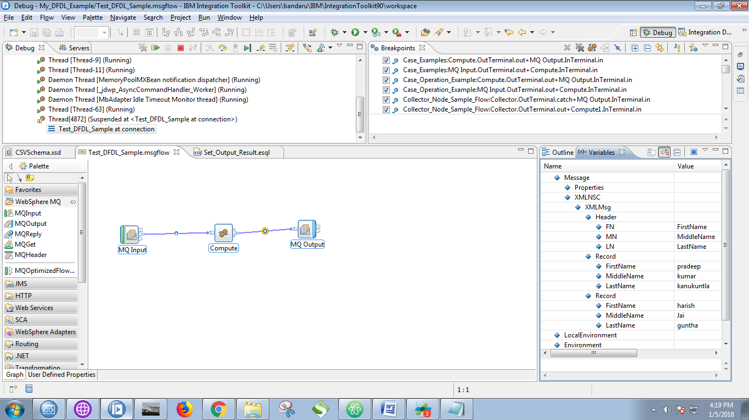

38. Now open RFHUtil and select your output queue and hit "Browse Q" button.

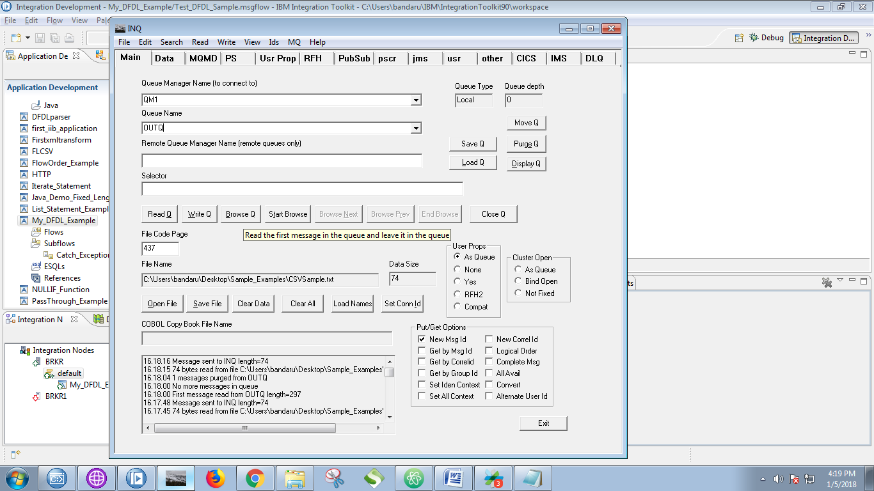

39. You can see your result under "Data" tab of the RFHUtil.

